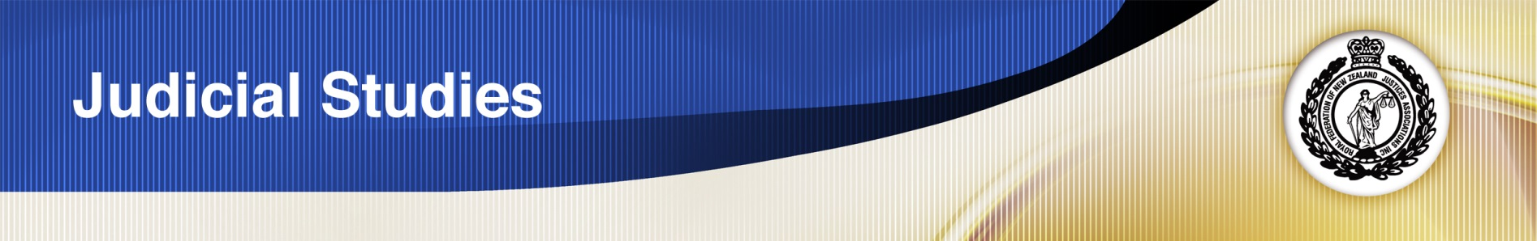

Worksheet 7.4

**These questions are intended to provide stimulation for purposeful reading of the textbook. No answers are provided. This worksheet is optional.**

**If you find the material confusing or challenging, stop and take a break, come back to it later. Also you do not need to labour over reading paragraphs that are specifically about jury trials or murder or sexual trials and so on. You will also find the summaries provided at the end of each chapter very useful.**

### Chapter 1 Principles, Purposes and Proof

* Where have the rules about evidence come from? How have they developed over time? (1.2.1)
* What are the main types of evidence? (Which do you think will be most common in JP court?) (1.4)
* In the jury direction given in *R v Wanballa* to explain the standard of beyond reasonable doubt, what did the court say about the relationship between ‘probably’ ‘very likely’ and ‘absolute certainty’?(1.5.2)
* Name the types of evidence.
* Name the burdens and standards of proof.

### Chapter 2 The Fundamentals of Admissibility; purpose, relevance and probative value

* What is the basic rule regarding irrelevant evidence?(2.1)
* How can you know or find out whether something is relevant or not?(2.2)
* What has the relationship between roses blooming and springtime got to do with evidence? (2.2.3)
* If I say that I am a woman, women are less likely to be convicted of careless driving, therefore I cannot have driven carelessly, what type of reasoning have I used?
* Would my evidence be useful in any way to the court?

### Chapter 3 Witness Questioning Rules

* The Act assumes everyone to be eligible to give evidence. However there are circumstances in which communications between individuals may remain **privileged (**private**).** What are these?
* Is communication between a married couple privileged?
* The ordinary way of giving evidence is in person in court. Although they will be rare in JP court, read about the other ways in paragraph 3.3.
* When might the court intervene during questioning?
* Which of the rules are most relevant for JP court?
* Can you think of circumstances in which a JP might receive evidence via a video link?

### Chapter 4 Hearsay: The Rule, the Rationale, the exceptions

* Why is hearsay evidence unreliable and ‘dangerous’ to a court? (4.2.1)
* An out of court statement that is offered to prove simply that the statement was made is not a hearsay statement. How can a Justice learn to distinguish *hearsay uses* from *hearsay evidence?* (4.4.1(2))

### Chapter 5 Evidence of veracity or propensity

* What are the standard terms and/or definitions for veracity and propensity? Make sure you are clear what they mean in everyday life as well as in court.
* When is evidence about a person’s veracity admissible? (5.4)
* When may the prosecution offer propensity evidence about a defendant? (5.5.3)
* You do not need to read pages 198 (from (f)) to 214 (up to the summary) These pages are about evidence in sexual offending cases -which Justices do not have jurisdiction over.
* Open the flowchart on page 216, and the Evidence Act in the Legislation website. Study the flowchart with reference to the sections of the Act.

### Chapter 6 Defendants’ statements and improperly obtained evidence

**Keep in mind that defendants’ statements (especially confessions) are rarely offered in evidence in JP cases.**

* Where a statement is excluded by a Judge because he or she is satisfied it was influenced by oppression (s29) to what extent does it matter whether or not it was true?
* Review your knowledge of the Bill of Rights Act 1990. What is the relationship between it and the Evidence Act s30(5)? (6.3.3)

### Chapter 7 The privilege against self-incrimination

* What is the “cruel trilemma”? (7.2.1)

**Keeping in mind that the onus is on the prosecution to prove the defendant’s guilt and that the defendant has a right to silence both before and during a trial:**

* What are the rules about *drawing an inference* or *being invited to draw an inference* when a defendant does not give evidence?(7.2.2 and 7.2.3)

### Chapter 8 Evidence of experts and identification

* What are the two types of opinion evidence that are admissible?
* What boundaries are there on each type of admissible opinion evidence?

**Keeping in mind that in most JP cases the identification of the defendant is not at issue:**

* Who is the one person the Act specifically allows to be visually identified? (8.5)
* Why is eyewitness identification considered to be usually flawed?
* What is dock identification?